**Design Document**

Kaloyan Aleksiev – Individual Project

Online inventory for a delivery company

1. Entity relation diagram

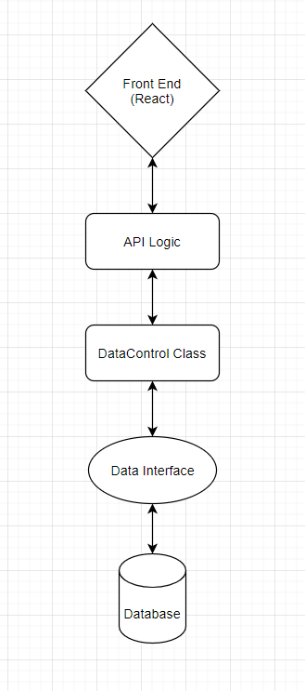

I chose to use this design not only because it guarantees that the SOLID principles of object oriented programming will be respected, but also because it was recommended by a technical teacher.

2. Back-End framework choice

My back-end framework of choice is SpringBoot. The reason I went with it instead of Jersey is because I feel it is more beginner-friendly with all of its useful documentation and guides, thus making it easier for me to understand how it works and to create everything that I will need for the project.



3. Front-End framework choice

The framework I chose to work with for my front-end is ReactJS. After doing the research and comparison between React, Angular and Vue along with my group project teammates, I decided that React would be the most interesting one to begin with. Thanks to it being the most used one out of the three, it has countless articles/tutorials about it on the web, making it very easy to find information in case I get stuck. So far I have been enjoying it.